**Prepare Lab Sheet of MYSQL Statements for following.**

1. Create a database named “Yourname_Roll_COMPANY” e.g.: Atiz_02_Company and then create following tables within the database. Specify proper primary keys and the needed constraints while defining the tables. Use appropriate data types for the attributes.

CREATE DATABASE Kaushal_13_Company;

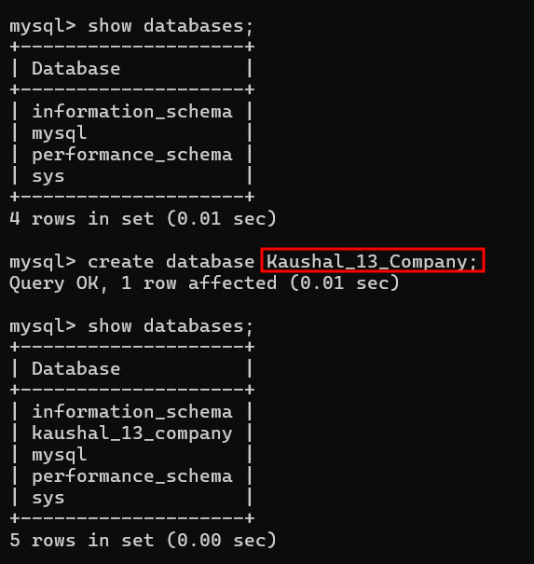

1. Employee (SSN, Ename, Gender, Bdate, Address, Salary, Ono, Years_of_experience); whereOno is a foreign key referencing to the Office table. Set default value of salary to 0.00. The Ename should not be null. Set SSN to auto increment. The Ename and address should be varchar, Gender should be char(1), Bdate should be date type, Salary should be decimal type with two digits after decimal.Years_of_experience should be integer. Use Check constraint for gender as CHECK (Gender  [IN](http://localhost/phpmyadmin/url.php?url=https://dev.mysql.com/doc/refman/5.5/en/comparison-operators.html#function_in) (‘M’, ‘F’))

1. Office (Onumber, Oname, Country); where Oname should not be NULL. Country should be varchar.

1. Project (Pnumber, Pname, Plocation, Onumber); where Onumber is a foreign key referencing Office table. Create a constraint name fk_pro for the foreign key. Pname should be unique and should not be null. Both Pname and Plocations should be of type varchar(40).

1. Works_on( ESSN, Pno); where ESSN references Employee SSN and Pno references to Pnumber from Project . Set cascade on update and cascade on delete to both

**Ans:-**

**DELETE CASCADE**: When we create a foreign key using this option, it deletes the referencing rows in the child table when the referenced row is deleted in the parent table which has a primary key.

**UPDATE CASCADE**: When we create a foreign key using UPDATE CASCADE the referencing rows are updated in the child table when the referenced row is updated in the parent table which has a primary key.

1. Dependents(Did, Dname, Dage, SSN); where SSN is Foreign key referencing the employee. Set NULL on delete and on update to the foreign key. Add constraint age_constraint using CHECK(Dage<16).

Constraints are rules or conditions that are applied to the data within a database for data integrity and consistency.

Check Constraints is used to check the age to be less than 16 while inserting the data.

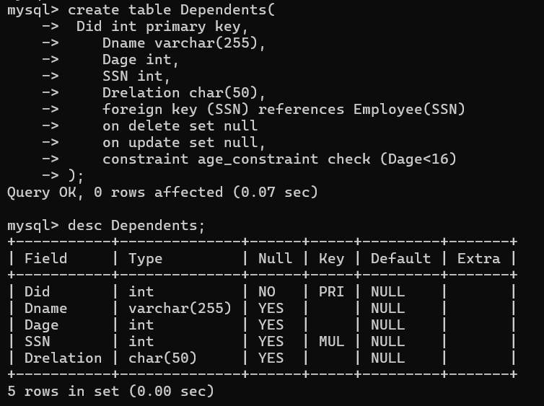

1. Alter table Dependent and modify the attribute Drelation of type Char(50) to Varchar(50)

Altered the table to modify the data type of Drelation column

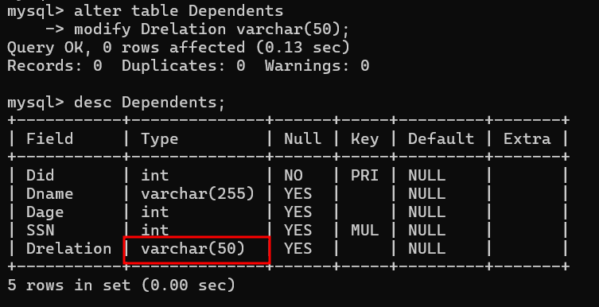

1. Insert at least five tuples into the tables. (Illustrate insertion of single tuple and multiple tuples both). During insertion insert following as well.

There should be one record in the Employee table having Ename “Your name” i. e. Deric and SSN “Your roll number” e.g. 6.

Similarly one of the tuple in employee should have salary 30000.

There should be one record in the Project table having Pname =“Your name_ProjMDS” and Pnumber = 2*Your Roll number.

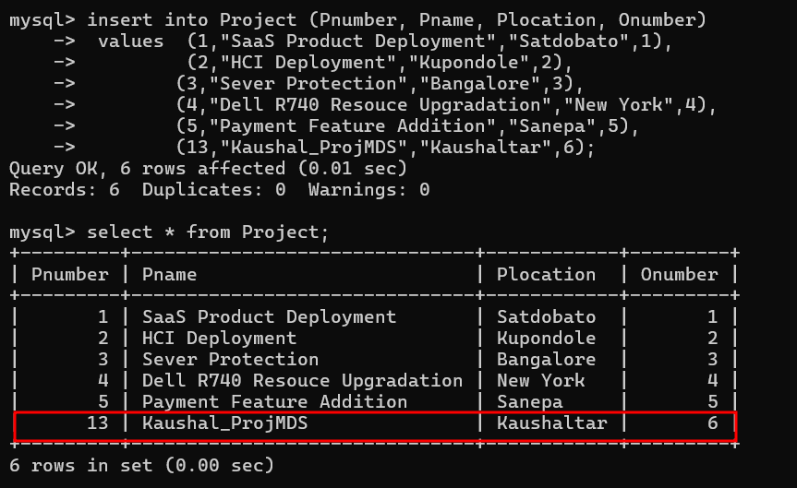

One of the tuple in Office table should have office name “Yourname_Office_Roll” i.e. Deric_Office_06.

In addition, there should be one tuple in office table having office name Yourname_Ncell_Roll.

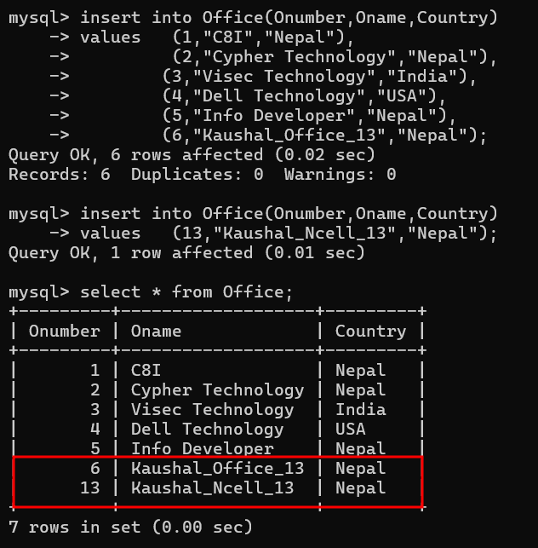

“Works_on” Table

In the dependents table insert the rows with Dname and Drelation having values from your family. For example, Deric has his elder brother and mother as his dependents. So the table will have records with values Dname=Denish and Drelation=Brother and Dname=Gayatri and Drelation=Mother. Take assumptions based on your family members while inserting the values.

But insert query violates the check constraints i.e. <16 then it restricts the query execution.

For mother record age

1. Update the name of office having office name “Yourname_Ncell_Roll” to “Yourname_Ntc_Roll”.

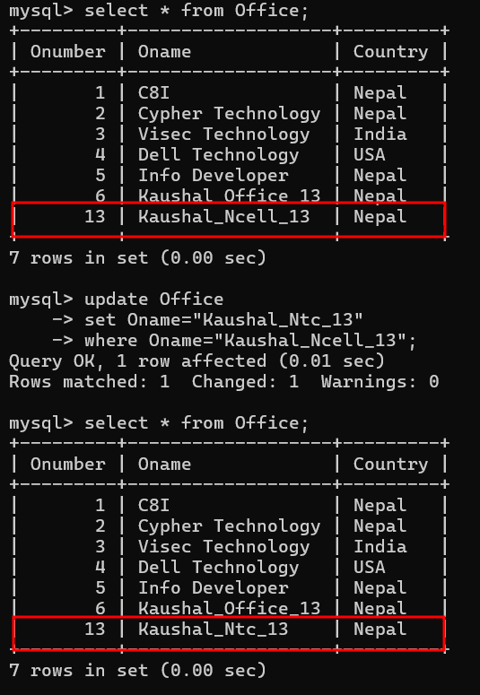

1. Delete those employees whose SSN is 1. {{{{Got null on Dependent SSN}}}}

Here, after deleting the primary key record, foreign key on “Dependents” table referencing the “Employee” SSN is set to NULL.

Here, after deleting the primary key record, foreign key on “Works_on” table referencing the Employee SSN is also Deleted to maintain integrity.

1. Alter table Project to rename the attribute in Plcoation to Proj_location

1. Select tuples from all of the tables individually.

1. Drop the table Works_on. Make sure to export your database before you drop it so that you can recover.

1. Drop the constraint age_constraint from dependent table

After dropping the Age check constraint we will be able to insert age value greater than 16

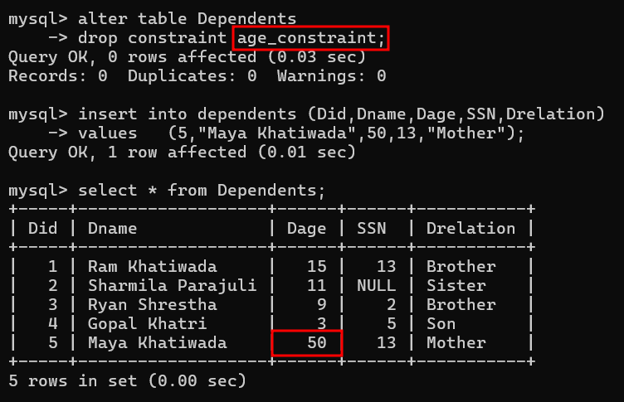

1. Drop the database COMPANY. Make sure to export your database before you drop it so that you can recover.

